Vocabulary Quiz 5 Level 2 Words 19-35
Word | Part of Speech | Arabic | Meaning | Example | Picture
pence | noun |  | a small British brown coin (plural); one penny, two pence | There are a hundred pence in a pound. | 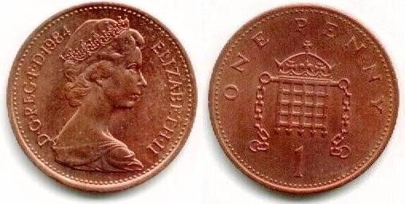
per | prep |  | for each
post office | noun
pound | noun
real | adjective
receipt | noun
rent | noun / verb
rented | adjective
sheet | noun
shut | verb/ adjective
size | noun
stamp | noun / verb
steal | verb
tidy | adjective
upset | adjective
upsetting | adjective
worse/worst | adjective

