Vocabulary Quiz 4 Level 2 Words 1-18
Word | Part of Speech | Arabic | Meaning | Example | Picture
accident | noun |  | an bad event that happens when you don’t expect it and you have damage, injury or death | There has been a car accident on the motorway, but no-one was injured. | 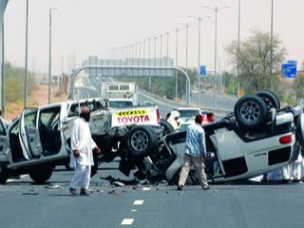
actually | adverb
almost | adverb
already | adverb
appointment | noun
broken | adjective
carefully | adverb
competition | noun
cover | noun/verb
crowd | noun
dream | noun/verb
entrance | noun
ever | adverb
fit | noun/verb/ adjective
glove | noun
goal | noun
hill | noun
least | adverb

