Vocabulary Quiz 2 Level 2 Words 19-35

Word | Part of Speech | Arabic | Meaning | Example | Picture
less | adj. |  | a smaller quantity compared to another one | There is less sand in the hourglass to the right. | 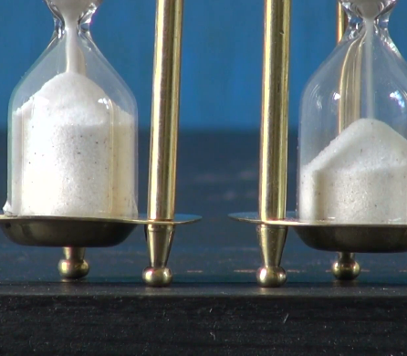
matter
memory
must
negative
own
perfect
physics
programme
record
science
software
staff
stairs
still
suit
useful

