Messi
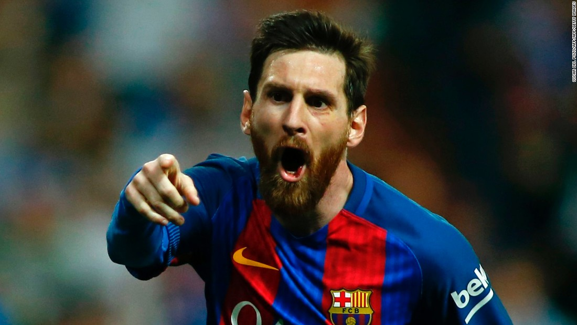
How old _______ he?
He __________ 30.

How many children _______ he have?
He _______ two children.

Who ____________ he play for?
He ______________ for FC Barcelona

__________ Messi love football?
Yes, he _______________.

________ he married?
Yes, he _____________.

Why ___________ Messi choose FC Barcelona?
The Sporting Director for FC Barcelona saw Messi play and asked him to join the team.

